Mock screens for the Unified portal:

Suggest to revise spacing as:

Enquiry Portal for

Non-locally Trained Doctors

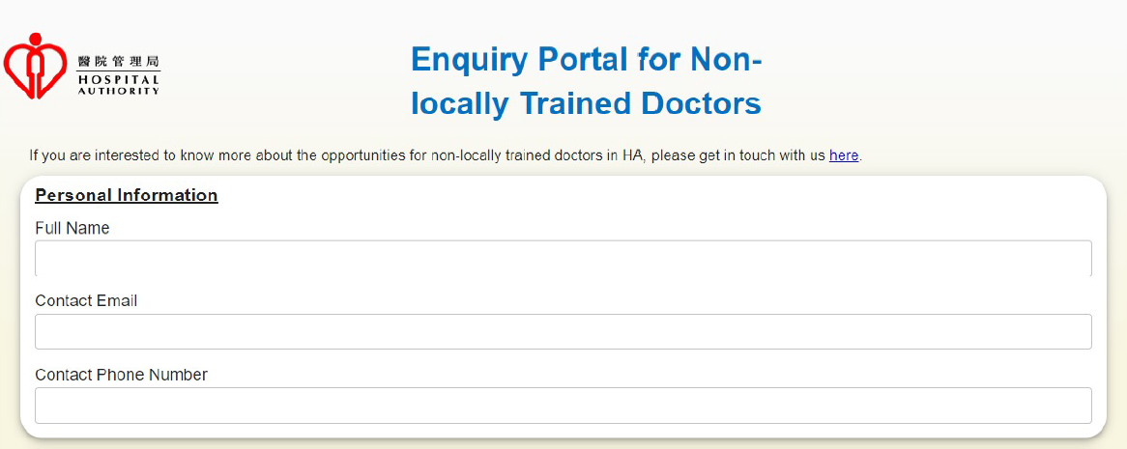

Hong Kong Permanent Resident

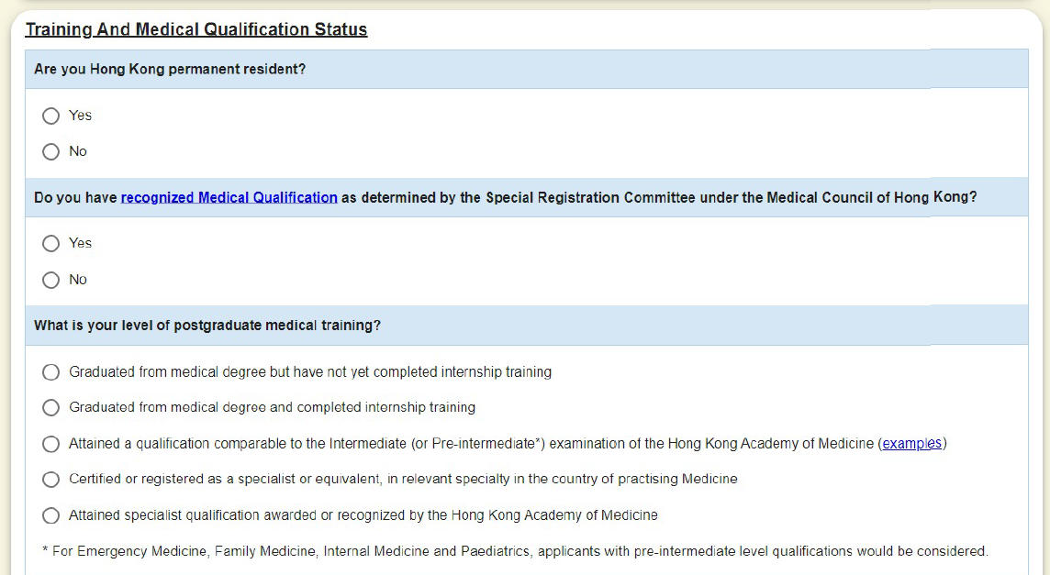

Recognized Medical Qualification

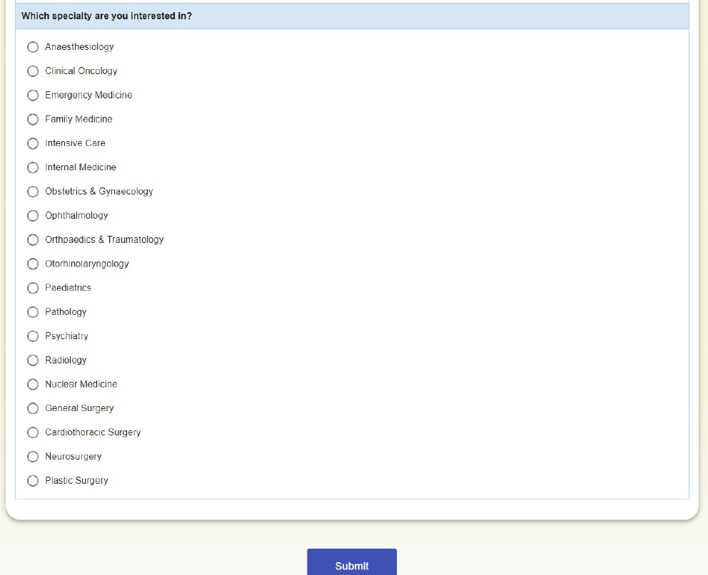

Add one more questions:

“Where did you learn about the recruitment of non-locally trained doctors in HA?”

* HA website
* Medical conference
* Medical journal
* Newspaper
* On-line Media
* Relatives & friends

After submission, successfully message will show up:

